User Manual for Photobomber



Launching the application
- After placing the executable where you desire, double click on the exe icon to launch the program. On first startup it may take a moment while the program initializes for the window to come up.

The Front Page
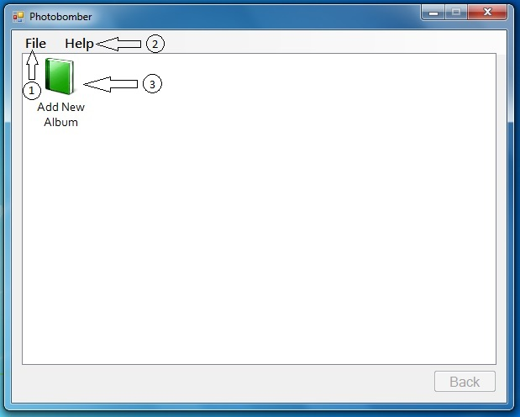
- File Menu: This menu contains functions to add a new album, add photos to an album, and exit the program.
- Help Menu: You can get to about information for this program through this menu.
- Add New Album icon: Instead of going through the file menu, you can double click on this icon to add a new album.

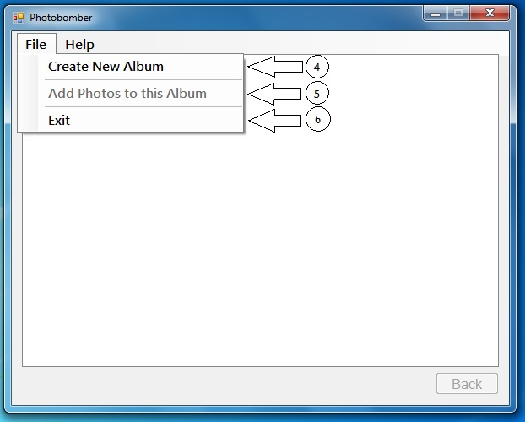
- Create New Album: Click here to add a new album to the program.
- Add Photos to this Album: This is greyed out because at this screen you are not in an album. When you go into an album this will be clickable.
- Exit: Click here to exit the program.

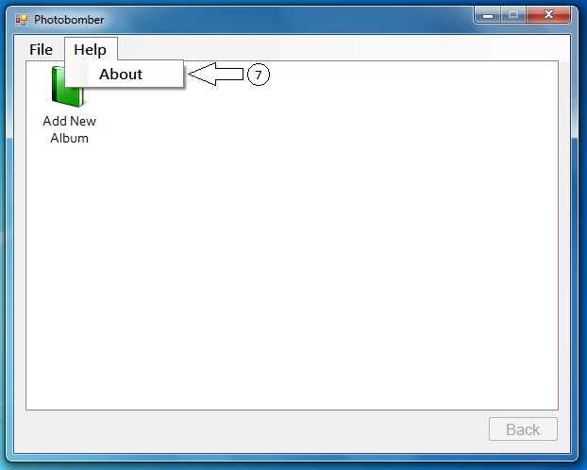
- About: Click here to view about information.

Adding an Album
- Double click on #3 OR single click on #1 then single click on #4 on the Front Page.
- The following dialogue will appear:
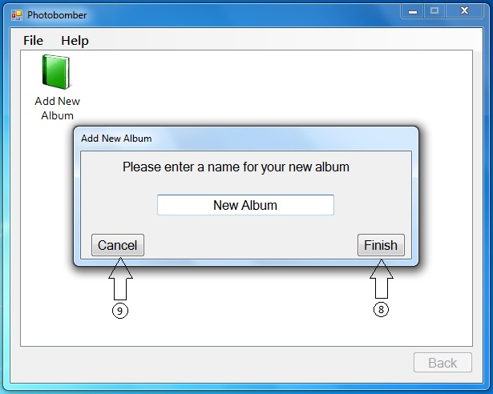
- Type a name into the text box and click Finish(#8) to add the new album with your chosen name. Note, your name must be at least two characters long, cannot contain any special characters, and cannot start or end with spaces. Maximum length for an album name is 16 characters. If you change your mind, just hit Cancel(#9)

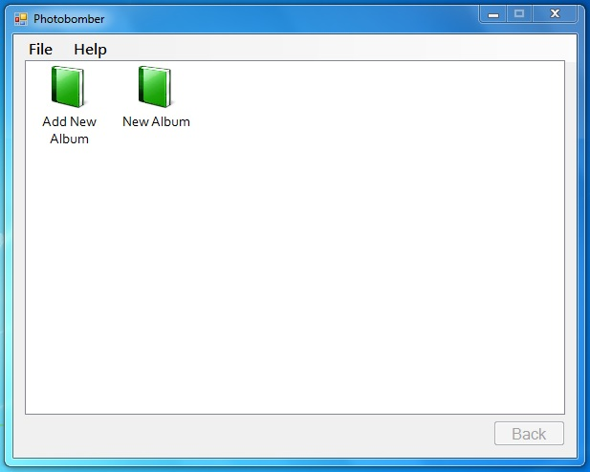
- Your new album will appear after you click finish!

Viewing an Album and adding Photos to it
- Now that your new album is created you may want to add photos to it. Double click on the icon for your new album(#10) to view it.
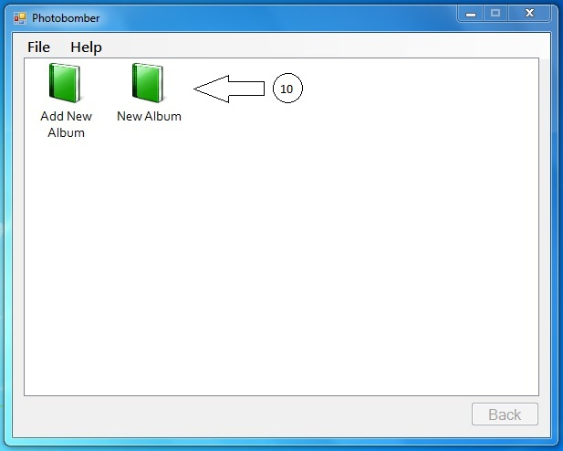

- You should now be at a screen like the one below.
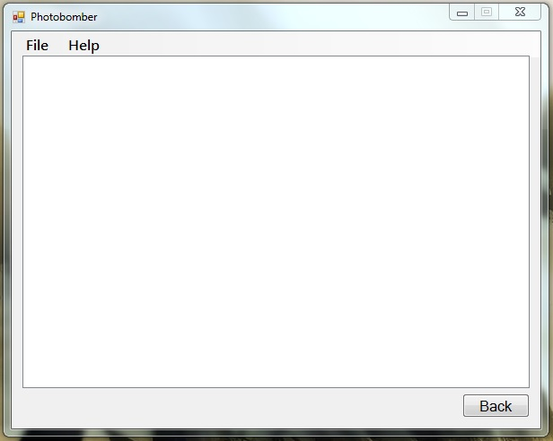

- To import pictures you want to click File(#11) and then click Add Photos to this Album(#12). To go back to the main view click the Back button(#13)
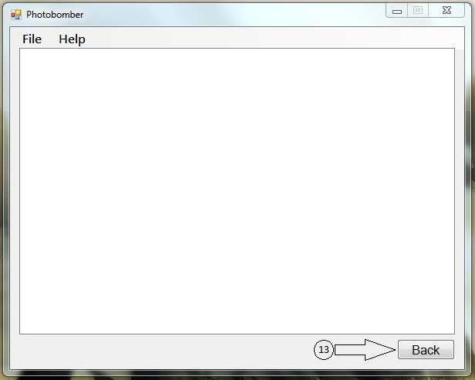

- A file browser should open. Use it to navigate too and select the photos you would like to import and then hit open.
- A progress bar will appear while the photographs are importing. To cancel the import at any time hit Cancel. Otherwise, when the import finishes a Finish button will appear. Click it(#13) to finish importing the photographs.
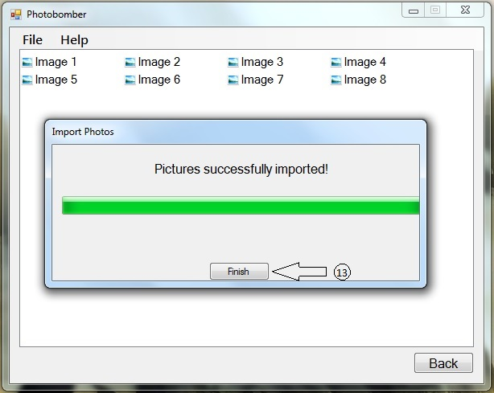

Viewing photos in your album
Once you have photos in your album your screen should look similar to below:
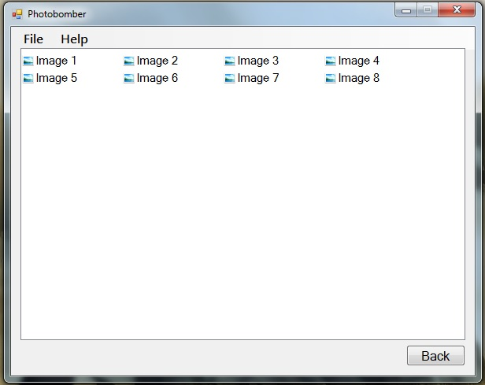

- To view a picture, double click on its name. It will open up a picture view like below. You can also right-click on an image and select View.
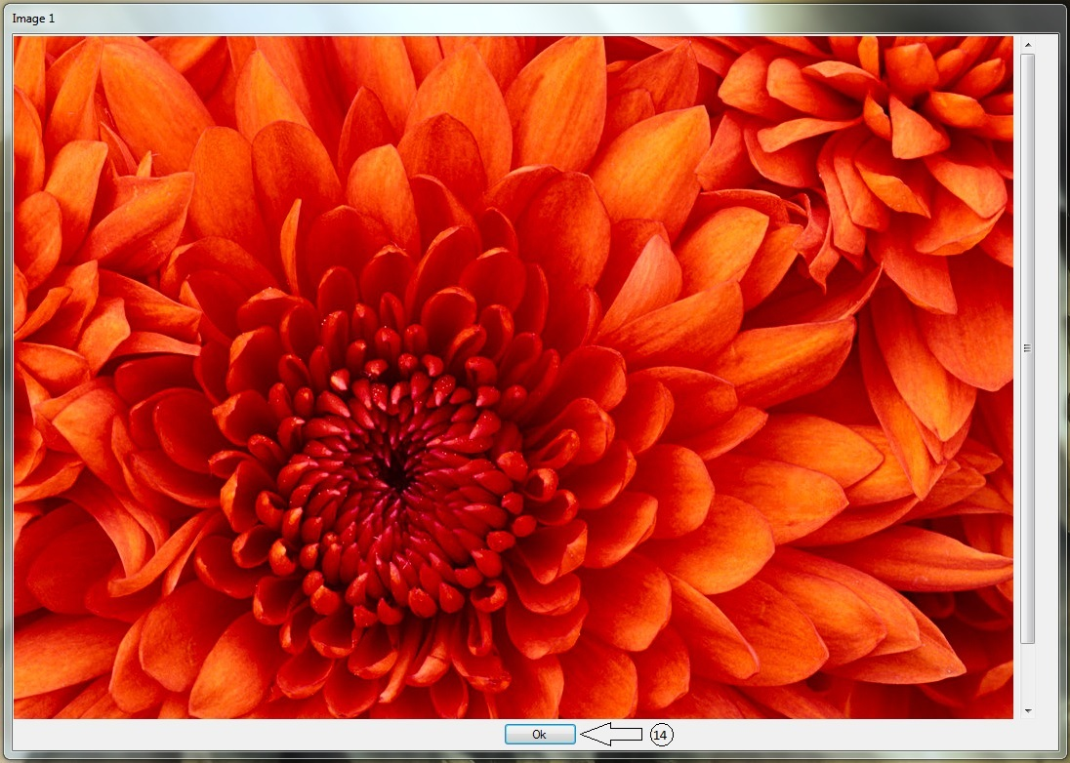
- Click the Ok button(#14) to close the view.

Renaming Photos in your album
- To rename a photo, right-click its name and select Rename. It will allow you type a new name in. Note: Like album names the photo name cannot contain any special characters, trailing or leading spaces, and must contain at least two characters. Maximum length is 32 characters.

